Section 3 Business Concern Certification for Contracting (Sample Form)

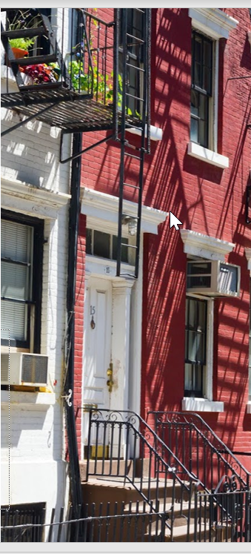
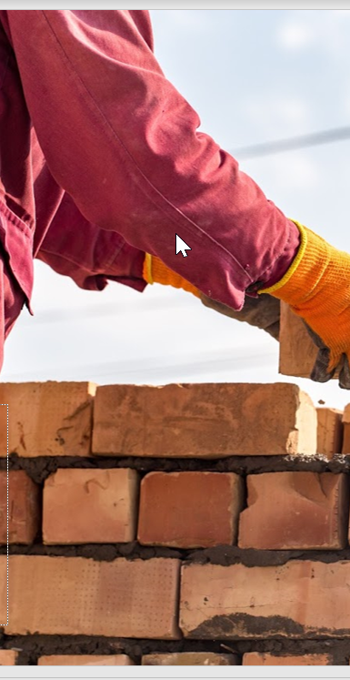
About this Tool
Description: Businesses seeking a preference in contracting on applicable Section 3 projects may qualify as a Section 3 business concern if they meet the following criteria: At least 51 percent of the business is owned and controlled by low- or very low-income persons, or at least 51 percent of the business is owned and controlled by current public housing residents or residents who currently live in Section 8-assisted housing, or over 75 percent of the labor hours performed for the business over the prior three-month period are performed by Section 3 workers.
This tool is designed to help grantees and their subrecipients, contractors, and subcontractors comply with the Section 3 requirements and achieve the Section 3 goals. It is intended to be a sample form to help grantees certify and track Section 3 business concerns seeking a preference in contracting.
How to Adapt this Document: This document is intended to be used as a reference tool to help grantees certify Section 3 business concerns and provide the appropriate records to support the business’ Section 3 status claims. Grantees are encouraged to adapt the form to fit the resources within their individual communities and to meet the needs of their program.
Source of Document: This document was developed by consultants affiliated with the consulting firm ICF.
Disclaimer: The following is a sample Section 3 Business Concern Certification form that PHAs or Community Development Offices may wish to use to begin developing their own form. They may work with their legal counsels to ensure it meets all local and state laws.
This resource will be part of a Section 3 Toolkit coming Fall of 2021. It will be hosted on the HUD Exchange at https://www.hudexchange.info/.

Updated as of: December 20, 2021

Section 3 Business Concern Certification for Contracting (Sample Form)
Instructions: Enter the following information and select the criteria that applies to certify your business’ Section 3 Business Concern status.

Business Information
Name of Business
Address of Business
Name of Business Owner
Phone Number of Business Owner
Email Address of Business Owner

Preferred Contact Information
☐ Same as above
Name of Preferred Contact
Phone Number of Preferred Contact

Type of Business (select from the following options):
☐Corporation ☐Partnership ☐Sole Proprietorship ☐Joint Venture

Select from ONE of the following three options below that applies:
☐ At least 51 percent of the business is owned and controlled by low- or very low-income persons (Refer to income guidelines on page 4).
☐ At least 51 percent of the business is owned and controlled by current public housing residents or residents who currently live in Section 8-assisted housing.
☐ Over 75 percent of the labor hours performed for the business over the prior three-month period are performed by Section 3 workers (Refer to definition on page 4).

(frontside)
Business Concern Affirmation
I affirm that the above statements (on the frontside of this form) are true, complete, and correct to the best of my knowledge and belief. I understand that businesses who misrepresent themselves as Section 3 business concerns and report false information to [insert name of recipient/grantee] may have their contracts terminated as default and be barred from ongoing and future considerations for contracting opportunities. I hereby certify, under penalty of law, that the following information is correct to the best of my knowledge.
.
Print Name:
Signature: Date: __________
*Certification expires within six months of the date of signature
Information regarding Section 3 Business Concerns can be found at 24 CFR 75.5

FOR ADMINISTRATIVE USE ONLY

Is the business a Section 3 business concern based upon their certification? □YES □NO

EMPLOYERS MUST RETAIN THIS FORM IN THEIR SECTION 3 COMPLIANCE FILE FOR FIVE YEARS.

(backside)

The City of (insert locality here)

Or

the (insert name here) Housing Authority

Section 3 Income Limits

Eligibility Guidelines
The worker’s income must be at or below the amount provided below for an individual (household of 1) regardless of actual household size.
Individual Income Limits for City of (insert locality here)
FY 20 (insert year here)
Income Limits  Category | FY 20 (enter year here)  Income Limits
Extremely Low Income Limits
(30%)
Very Low Income Limits
(50%)
Low Income Limits
(80%)
See https://www.huduser.gov/portal/datasets/il.html for most recent income limits.
Section 3 Worker Definition:
- A low or very low-income resident (the worker’s income for the previous or annualized calendar year is below the income limit established by HUD); or
- Employed by a Section 3 business concern; or
- A YouthBuild participant.
Targeted Section 3 Worker Definition:
- Employed by a Section 3 business concern or
- Currently meets or when hired met at least one of the following categories as documented within the past five years:
  - A resident of public housing; or
  - A resident of other public housing projects or Section 8-assisted housing; or
  - A YouthBuild participant.

